Ex.No:16: SIMULATION AND ANALYSIS OF UNIFORM AND NON-UNIFORM QUANTIZATION USING MATLAB

Objective 1:
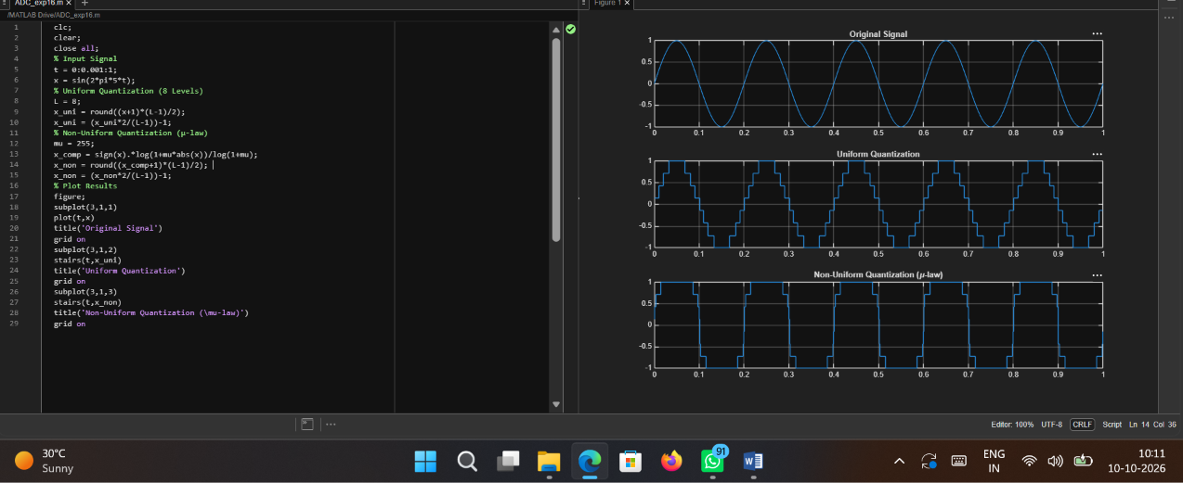
Code:
clc; clear; close all;
% Input Signal t = 0:0.001:1;
x = sin(2*pi*5*t);
% Uniform Quantization (8 Levels)

L = 8;
x_uni = round((x+1)*(L-1)/2); x_uni = (x_uni*2/(L-1))-1;
% Non-Uniform Quantization (μ-law) mu = 255;
x_comp = sign(x).*log(1+mu*abs(x))/log(1+mu); x_non = round((x_comp+1)*(L-1)/2);
x_non = (x_non*2/(L-1))-1;
% Plot Results figure; subplot(3,1,1) plot(t,x)
title('Original Signal') grid on
subplot(3,1,2) stairs(t,x_uni) title('Uniform Quantization') grid on
subplot(3,1,3) stairs(t,x_non)
title('Non-Uniform Quantization (\mu-law)') grid on

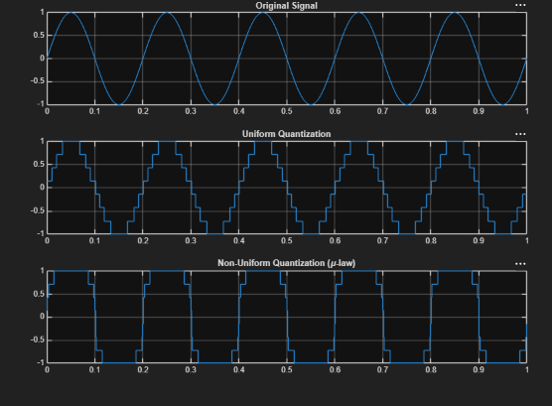
Output:

